Student’s Name
Institution
Course Name & Code
Lecturer
Due Date

Rhetorical Analysis of Ads
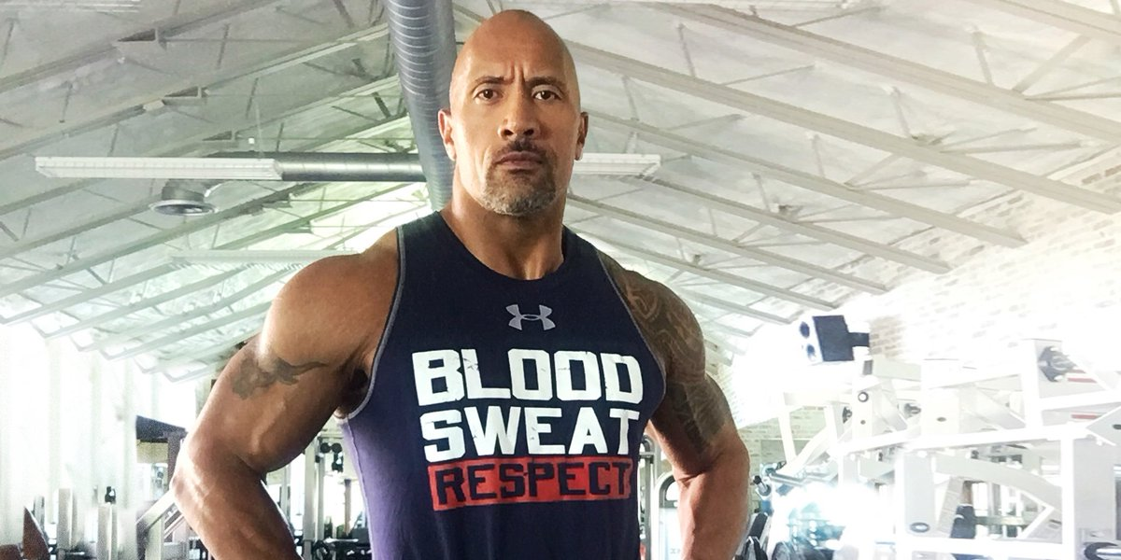
Audience analysis
This is one of the ads that Dwayne Johnson “the Rock” has done for Under Armour clothing apparel. The ad is intended for the audience that wants to feel that they are “hardest the worker in the room”. Thus, the picture is taken from the Rock’s gym and the Rock is wearing an Under Armour sleeveless top tank and it is motivational for gym enthusiasts to work harder.
Thesis Statement
Advertising is one of the strategies that companies use to create awareness among consumers about the products or services that they produce. Creation of ads is not just for the sake of it, but companies seek to touch three key aspects of the consumer for them to woo them to use the advertised products. Thus, the ads have to appeal to the emotional aspect of consumers, the logical aspect, and then appeal to the character of the consumers. Basically, the three rhetorical appeals are pathos, logos, and ethos. There is no doubt that Dwayne Johnson uses rhetorical appeals in the Ender Armour ad where he appears in his gym with a sleeveless top tank. Under Armour has taken advantage of Dwayne Johnson because he is someone who is widely known world over from movies and WWE. Dwayne Johnson is likeable and respected and thus once the ad get to the audience they will automatically relate with the Under Armour gym garments. Thus, “BLOOD. SWEAT. RESPECT” is a persuasive message in the top tank on The Rock that cements the persuasive aspects of the message in the whole ad since it asks people to work harder in gyms while wearing Under Armour tops.
Analysis of pathos in the ad
Pathos in ads mean the message in ads appeal to the audience’s emotional aspect. Thus, in the ad where The Rock appears is in his gym with weights and other gym equipment in the background, the message on his top tank is “BOOD. SWEAT. RESPECT”. The message appeals to the audience’s emotions since they know that they have to burn some blood for them to sweat. Blood is a scary thing to many people but gym enthusiasts know that they have to burn some calories (blood) in the gym for them to become better and earn “RESPECT”. In essence, the background of the photo is also full of gym equipment and lovers of those equipment will be emotionally drawn to the background and inspect to see the pieces of equipment that they like. On the other hand, the eyes of the main character in the ad, The Rock, are fixated on the audience and that look seems to look like the audience is familiar with The Rock, evoking emotions. Thus, by a large extent, the ad resonates with the audience’s emotions and that makes the audience relate with the Under Armour products for their gym practices and other sporting activities.
Analysis Logos
Logos in ads refer to ways of designing ads so that they can appeal to the logic of the audience. In a number of ways, the ad by the rock has logical appeals on the audience that gets to see it (Suhada et al. 306). The message is that the rock did not come from somewhere but by being “The hardest worker in the worker”. Logically, without hard working, one cannot earn anything in the world, let alone “RESPECT” that is conspicuously written on The Rock’s top tank. The Rock gives reasons for his success and fame and being “the hardest worker in the Room” is one of them and being the hardest worker means burning ones’ “BLOOD” and “SWEAT”. For people who have been to gyms, sweating for them is synonymous to working incessantly and the fact that they can work and the garments on them are tough and cannot burst or rupture gives them further reasons to be attracted to Under Armour products. It therefore means, once one in Under Armour top tank, they cannot stop working in the gym because their top tank have burst up. Hence, the ad appeals logically to many athletes seeking to work hard in the gym to better their game and become successful because working hard as per the hard is the way to success and that can be made possible by being in Under Armour top tanks and other sporting apparel that do not tear or burst up while working.
Analysis of Ethos in the ad
Ethos are used in the ads to reveal reliability, honesty, products that are credible (Romanova & Smirnova 62). The ad has The Rock as one of their image pushers and he is very famous person across the world. It therefore means that with is superior social status and authority in sports like American Football, The Rock’s image use appeals to the ethos of the audience that gets to see the ad. The Rock has not had any ethical controversies and neither has he been associated with social deprivations like unethical scandals. Therefore, Under Armour using him as their brand’s ambassador sends a message to the audience that their products are anchored on accepted social conducts not only in sports but also in other social sectors.
Conclusion
It is important to restate that ads are ways of creating necessary marketing awareness for companies’ products. The audience needs to relate to the products and the three ways through which they relate to the product are through their ethics, logic, and emotions. Logos mean logic, ethos mean ethics, and pathos mean emotional appeal in ads. The Rocks Under Armour ad with inscriptions “BLOOD. SWEAT. RESPECT” appeals to the audience by relating to their emotion, ethical standards, and even their logic since The Rock is a global image and is a respected person who has worked hard through the years.

Work Cited
https://www.google.com/url?sa=i&url=https%3A%2F%2Ftwitter.com%2Ftherock%2Fstatus%2F820689230053548032&psig=AOvVaw0ROafsDUQQEXii1nMo2cjf&ust=1632202992741000&source=images&cd=vfe&ved=0CAsQjRxqFwoTCNDe5PvrjPMCFQAAAAAdAAAAABAs
Romanova, Irina D., and Irina V. Smirnova. "Persuasive techniques in advertising." Training, Language and Culture 3.2 (2019): 55-79.
Syuhada, Rifka Fani, Iskandar Abdul Samad, and Kismullah Abdul Muthalib. "LANGUAGE STYLES USED IN EDUCATIONAL ADVERTISEMENT OF THE JAKARTA POST NEWSPAPER." English Education Journal 11.3 (2020): 303-315.

